

**Specification**



|  |
| --- |
| **OpenPEPPOL AISBL** |
|  |
| **Peppol Transport Infrastructure**  **ICT - Models**  **Service Metadata Publishing (SMP)**  **Version: 1.2.0**  **Status: In use**  **Editors:**  **Gert Sylvest (NITA/Avanade)  Jens Jakob Andersen (NITA)  Klaus Vilstrup Pedersen (DIFI)  Mikkel Hippe Brun (NITA)  Paul Fremantle (NITA/WSO2)** | |

|  |  |  |
| --- | --- | --- |
| **Project co-funded by the European Commission within the ICT Policy Support Programme** | | |
| **Dissemination Level** | | |
| **P** | **Public** | **X** |
| **C** | **Confidential, only for members of the consortium and the Commission Services** |  |

**Revision History**

|  |  |  |  |
| --- | --- | --- | --- |
| Version | Date | Description of changes | Author |
| 1.0.0 | 2010-02-15 | First version (pending EC approval) | Mikkel Hippe Brun, NITA |
| 1.0.1 | 2010-10-01 | EC approved | Klaus Vilstrup Pedersen, DIFI |
| 1.1.0 | 2012-08-15 | Make room for alternative Transport Protocols e.g. AS2 | Klaus Vilstrup Pedersen, DIFI |
| 1.2.0 | 2020-04-20 | Updated the references  Improved layout  Explicitly allowing Content-Type “application/xml” as it is equivalent to “text/xml” (chapter 5.1)  Removing the requirement that the encoding attribute value is case sensitive (chapter 5.2)  Change “is not” to “MUST NOT” in chapter 5.5  Replaced the references to the BusDox Common Definition document (BDEN-CEDF)  Added clarifications on ServiceActivationDate and ServiceExpirationDate  Linking peppol-smp-types-v1.xsd in the Appendix | Philip Helger, OpenPEPPOL OO |

**Statement of originality**

This deliverable contains original unpublished work except where clearly indicated otherwise. Acknowledgement of previously published material and of the work of others has been made through appropriate citation, quotation or both.

**Statement of copyright**



*This deliverable is released under the terms of the Creative Commons Licence accessed through the following link: http://creativecommons.org/licenses/by-nc-nd/4.0/.*

*You are free to:*

***Share*** *— copy and redistribute the material in any medium or format.*

*The licensor cannot revoke these freedoms as long as you follow the license terms.*

# Contributors

**Organisations**

DIFI (Direktoratet for forvaltning og IKT)[1], Norway, [www.difi.no](http://www.difi.no)

NITA (IT- og Telestyrelsen)[2], Denmark, www.itst.dk

BRZ (Bundesrechenzentrum)[3], Austria, www.brz.gv.at

Consip, Italy

OpenPEPPOL

**Persons**

Bergthór Skúlason, NITA

Carl-Markus Piswanger, BRZ

Gert Sylvest, NITA/Avanade (editor)

Jens Jakob Andersen, NITA

Joakim Recht, NITA/Trifork

Kenneth Bengtsson, NITA/Alfa1lab

Klaus Vilstrup Pedersen, DIFI

Mike Edwards, NITA/IBM

Mikkel Hippe Brun, NITA

Paul Fremantle, NITA/WSO2

Philip Helger, BRZ/OpenPEPPOL OO

Thomas Gundel, NITA/IT Crew

# ****Table of contents****

Contributors 4

Table of contents 5

1 Introduction 6

1.1 Objective 6

1.2 Scope 6

1.3 Goals and non-goals 6

1.4 Terminology 6

1.4.1 Notational conventions 7

1.4.2 Normative references 7

1.4.3 Non-normative references 7

1.5 Namespaces 7

2 The Service Discovery Process 9

2.1 Discovery flow 9

2.1.1 Discovering services associated with a Participant Identifier 10

2.2 Service Metadata Publisher Redirection 10

3 Interface model 11

4 Data model 12

4.1 On extension points 12

4.1.1 Semantics and use 12

4.2 ServiceGroup 12

4.2.1 Non-normative example 13

4.3 ServiceMetadata 13

4.3.1 Redirection 14

4.3.2 Non-normative example 18

4.4 SignedServiceMetadata 18

4.4.1 Non-normative example 18

4.4.2 Redirect, non-normative example 19

5 Service Metadata Publishing REST binding 21

5.1 The use of HTTP 21

5.2 The use of XML and encoding 21

5.3 Resources and identifiers 21

5.3.1 On the use of percent encoding 22

5.3.2 Using identifiers in the REST Resource URLs 22

5.3.3 Non-normative identifier example 22

5.3.4 Implementation considerations 23

5.4 Referencing the SMP REST binding 23

5.5 Security 23

5.5.1 Message signature 23

5.5.2 Verifying the signature 24

5.5.3 Verifying the signature of the destination SMP 24

6 Appendix A: Schema for the REST interface 25

6.1 peppol-smp-types-v1.xsd (non-normative) 25

# Introduction

## Objective

This document describes the REST (Representational State Transfer) interface for Service Metadata Publication within the Business Document Exchange Network (BUSDOX). It describes the request/response exchanges between a Service Metadata Publisher and a client wishing to discover endpoint information. A client could be an end-user business application or an Access Point. It also defines the request processing that must happen at the client.

## Scope

This specification relates to the Technical Transport Layer i.e. BusDox specifications. The BusDox specifications can be used in many interoperability settings. In the Peppol context, it provides transport for procurement documents as specified in the Peppol Profiles.

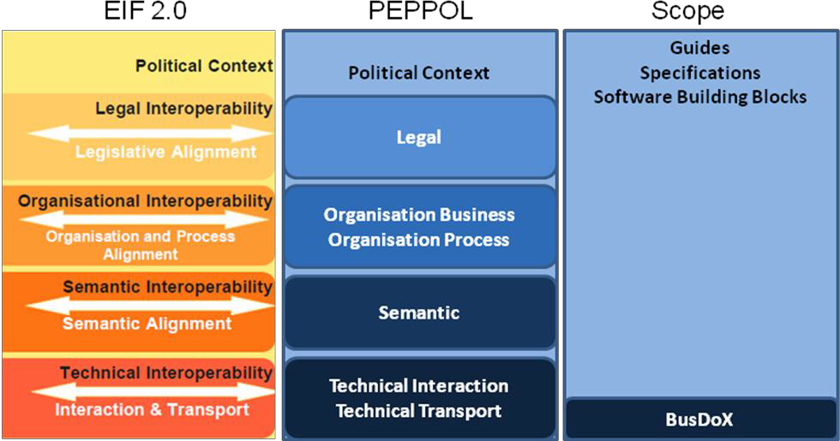

Fig. : Peppol Interoperability

## Goals and non-goals

The goal of this document is to define the REST lookup interface that Service Metadata Publishers (“SMP”) and clients must support. Decisions regarding physical data format and management interfaces are left to implementers of such a service.

Service Metadata Publishers may be subject to additional constraints of agreements and governance frameworks within instances of the BUSDOX infrastructure not covered in this specification, which only addresses the technical interface of such a service.

## Terminology

The keywords "MUST", "MUST NOT", "REQUIRED", "SHALL", "SHALL NOT", "SHOULD", "SHOULD NOT", "RECOMMENDED", "MAY", and "OPTIONAL" in this document are to be interpreted as described in RFC 2119 [RFC2119].

### Notational conventions

Pseudo-schemas are provided for each component, before the description of the component. They use BNF-style conventions for attributes and elements: "?" denotes optionality (i.e. zero or one occurrences), "*" denotes zero or more occurrences, "+" one or more occurrences, "[" and "]" are used to form groups, and "|" represents choice. Attributes are conventionally assigned a value which corresponds to their type, as defined in the normative schema. Elements with simple content are conventionally assigned a value which corresponds to the type of their content, as defined in the normative schema. Pseudo schemas do not include extension points for brevity.

<!-- sample pseudo-schema -->

<defined_element

required_attribute_of_type_string="xs:string"

optional_attribute_of_type_int="xs:int"? >

<required_element />

<optional_element />?

<one_or_more_of_these_elements />+

[ <choice_1 /> | <choice_2 /> ]*

</defined_element>

### Normative references

[XML-DSIG] “XML Signature Syntax and Processing (Second Edition)”, <http://www.w3.org/TR/xmldsig-core/>

[RFC3986] “Uniform Resource Identifier (URI): Generic Syntax”, <http://tools.ietf.org/html/rfc3986>

[WSA-1.0] “Web Services Addressing 1.0 – Core”,  
<http://www.w3.org/TR/2005/CR-ws-addrcore-20050817/>  
and “Web Services Addressing 1.0 - SOAP Binding”,  
<http://www.w3.org/TR/wsaddr-soap/>

[RFC2119] "Key words for use in RFCs to Indicate Requirement Levels", <http://www.ietf.org/rfc/rfc2119.txt>

[PFUOI4] “Policy for use of Identifiers 4.0”, <https://github.com/OpenPEPPOL/documentation/raw/master/TransportInfrastructure/PEPPOL-EDN-Policy-for-use-of-identifiers-4.0-2019-01-28.pdf>

### Non-normative references

[WSDL-2.0] “Web Services Description Language (WSDL) Version 2.0 Part 1: Core Language”, <http://www.w3.org/TR/wsdl20/>

[REST] “Architectural Styles and the Design of Network-based Software Architectures”, <http://www.ics.uci.edu/~fielding/pubs/dissertation/top.htm>

[BDEN-SML] “Service Metadata Locator Profile”, PEPPOL-EDN-Service-Metadata-Locator-1.2.0-2020-03-23.pdf

## Namespaces

The following table lists XML namespaces that are used in this document. The choice of any namespace prefix is arbitrary and not semantically significant.

|  |  |
| --- | --- |
| Prefix | Namespace URI |
| ds | http://www.w3.org/2000/09/xmldsig# |
| ids | http://busdox.org/transport/identifiers/1.0/ |
| smp | http://busdox.org/serviceMetadata/publishing/1.0/ |
| wsa | http://www.w3.org/2005/08/addressing |
| xs | http://www.w3.org/2001/XMLSchema |

# The Service Discovery Process

The interfaces of the Service Metadata Locator (SML) service and the Service Metadata Publisher (SMP) service cover both sender-side lookup and metadata management performed by SMPs. Business Document Exchange Network (BUSDOX) mandates the following interfaces for these services:

* Service Metadata Locator:
  + DNS-based resolve mechanism to locate individual SMPs
  + Management interface towards SMPs
* Service Metadata Publishers:
  + Discovery interface towards senders

This specification only covers the discovery interface for Service Metadata Publication services.

## Discovery flow

For a sender, the first step in the Discovery process is to establish the location of the Service Metadata relating to the particular Participant Identifier to which the sender wants to transmit a message. Each participant identifier is registered with one and only one Service Metadata Publisher. The sender looks up the endpoint for the Service Metadata Publisher using the DNS-based Service Metadata Locator service (this is a regular DNS resolve). The sender can then retrieve the metadata associated with the Participant Identifier. This metadata includes the information necessary to transmit the message to the recipient endpoint.

The diagram below represents the lookup flow for a sender contacting both the Service Metadata Locator and the SMP.

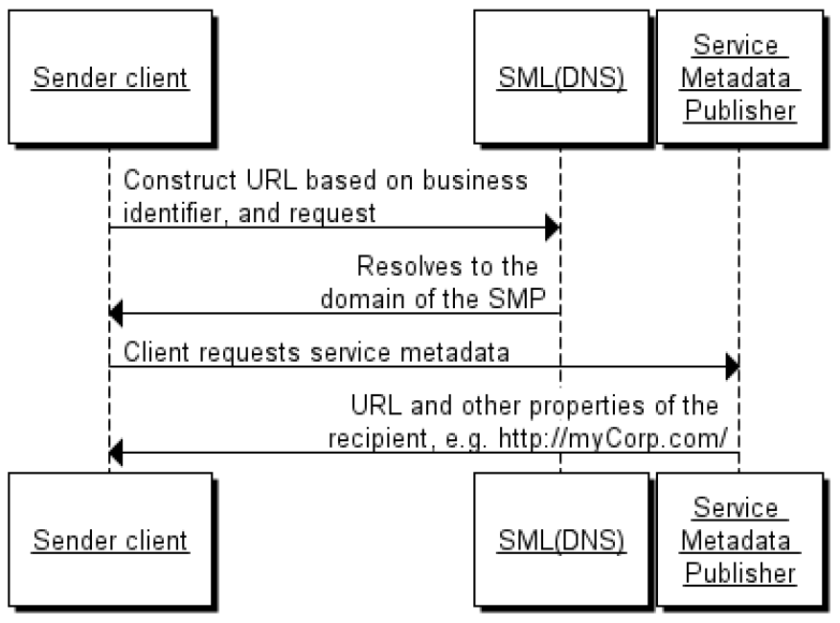

Fig. : Endpoint lookup with Service Metadata

Note: For optimization reasons, the discovery doesn’t have to be performed for every transfer if the necessary information for transfer is already cached from previous transmissions. Though necessary exception handling has to be in place i.e. new lookup has to be performed if the sending shows that information is outdated e.g. old endpoint address.

### Discovering services associated with a Participant Identifier

In addition to the direct lookup of Service Metadata based on participant identifier and document type, a sender may want to discover what document types can be handled by a specific participant identifier. Such discovery is relevant for applications supporting several equivalent business processes. Knowing the capabilities of the recipient is valuable information to a sender application and ultimately to an end user. E.g. the end user may be presented with a choice between a “simple” and a “rich” business process.

This is enabled by a pattern where the sender first retrieves the ServiceGroup entity, which holds a list of references to the ServiceMetadata resources associated with it. The SignedServiceMetadata in turn holds the metadata information that describes the capabilities associated with the recipient participant identifier

## Service Metadata Publisher Redirection

For each participant identifier, the SML may only point to a single SMP. There are cases however where the owner of a participant identifier may want to use different SMPs for different document types or processes. This is supported by Service Metadata Publisher Redirection.

In this pattern, the sender is redirected by the SMP to a secondary, remote SMP where the actual SignedServiceMetadata can be found. A special element within the SignedServiceMetadata record of the SMP points to the SMP that has the actual Service Metadata and certificate information for that SMP. The diagram below shows this flow:

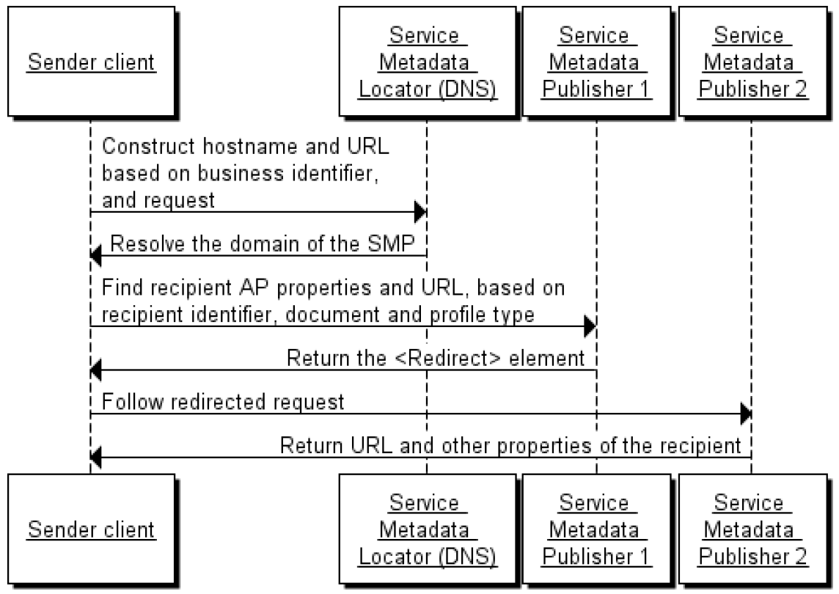

Fig. : Service Metadata Redirection

Note that only one degree of redirect is allowed; clients are not required to follow more than one redirect, i.e. a redirect resource cannot point to another redirect resource. Allowing one level of redirect permits the described use case to be realized, while avoiding the possibility of cyclic references and long chains of redirects

# Interface model

This specification defines a REST-based interface for retrieving Service Metadata, but does not specify interfaces for creating, updating, deleting and managing Service Metadata, or any internal data storage formats.

The goal is to allow the interface in this specification to expose data from many different Service Metadata back-ends, which may be based on any suitable technology such as for example RDBMS, LDAP, or UDDI.

Note that when adding or deleting Participant Identifiers in the SMP, an implementation of the SMP will need to reflect its custody of a Participant Identifier in the SML. Please see the SML specification [BDEN-SML] for a description of the processes and interfaces for doing this.

# Data model

This section outlines the data model of the interface. The data model comprises the following main data types:

* ServiceGroup
* ServiceMetadata / SignedServiceMetadata

Supporting data types for these main types are:

* ServiceInformation
* ServiceEndpointList
* ParticipantIdentifier
* DocumentIdentifier
* Redirect
* Process
* ProcessList
* Endpoint

Each of these data types is described in detail in the following sections.

## On extension points

For each major entity, extension points have been added with the optional <smp:Extension> element.

### Semantics and use

Child elements of the <smp:Extension> element are known as “custom extension elements”. Extension points may be used for optional extensions of service metadata. This implies:

* Extension elements added to a specific Service Metadata resource MUST be ignorable by any client of the transport infrastructure. The ability to parse and adjust client behaviour based on an extension element MUST NOT be a prerequisite for a client to locate a service, or to make a successful request at the referenced service.
* A client MAY ignore any extension element added to specific service metadata resource instances.

## ServiceGroup

The ServiceGroup structure represents a set of services associated with a specific participant identifier that is handled by a specific SMP. The ServiceGroup structure holds a list of references to SignedServiceMetadata resources in the ServiceList structure.

Pseudo-schema for ServiceGroup:

<smp:ServiceGroup>

<ids:ParticipantIdentifier scheme=”xs:string”>

xs:string

</ids:ParticipantIdentifier>

<smp:ServiceMetadataReferenceCollection>

<smp:ServiceMetadataReference href=”xs:anyURI” />*

</smp:ServiceMetadataReferenceCollection>

<smp:Extension>xs:any</smp:Extension>?

</smp:ServiceGroup>

Description of the individual fields (elements and attributes).

|  |  |
| --- | --- |
| Field | Description |
| ServiceGroup | Document element |
| ParticipantIdentifier | Represents the business level endpoint key and key type, e.g. a DUNS or GLN number that is associated with a group of services. See [PFUOI4] for information on this data type. |
| ServiceMetadataReferenceCollection | This structure holds a list of references to SignedServiceMetadata structures. From this list, a sender can follow the references to get each SignedServiceMetadata structure. |
| ServiceMetadataReference (0..*) | Contains the URL to a specific SignedServiceMetadata instance - see the REST binding section for details on the URL format. Note that references MUST refer to SignedServiceMetadata records that are signed by the certificate of the SMP. It MUST NOT point to SignedServiceMetadata resources published by external SMPs. |
| Extension | The extension element may contain any XML element. Clients MAY ignore this element. It can be used to add extended metadata to individual references to Service Metadata resources. |

### Non-normative example

Non-normative example of a ServiceGroup resource:

<?xml version=*"1.0"* encoding=*"utf-8"* ?>

<!--

This sample assumes that the service metadata publisher resides at "http://serviceMetadata.eu/".

It assumes that the business identifier is "0010:5798000000001".

-->

<ServiceGroup xmlns=*"http://busdox.org/serviceMetadata/publishing/1.0/"* xmlns:ids=*"http://busdox.org/transport/identifiers/1.0/"*>

<ids:ParticipantIdentifier scheme=*"busdox-actorid-upis"*>

0010:5798000000001

</ids:ParticipantIdentifier>

<ServiceMetadataReferenceCollection>

<ServiceMetadataReference href=*"http://serviceMetadata.eu/busdox-actorid-upis%3A%3A0010%3A5798000000001/services/busdox-docid-qns%3A%3Aurn%3Aoasis%3Anames%3Aspecification%3Aubl%3Aschema%3Axsd%3AInvoice-2%3A%3AInvoice%23%23UBL-2.0"*/>

</ServiceMetadataReferenceCollection>

<Extension>

<ex:Test xmlns:ex=*"http://test.eu"*>Test</ex:Test>

</Extension>

</ServiceGroup>

## ServiceMetadata

This data structure represents Metadata about a specific electronic service. The role of the ServiceMetadata structure is to associate a participant identifier with the ability to receive a specific document type over a specific transport. It also describes which business processes a document can participate in, and various operational data such as service activation and expiration times.

The ServiceMetadata resource contains all the metadata about a service that a sender Access Point needs to know in order to send a message to that service.

### Redirection

For recipients that want to associate more than one SMP with their participant identifier, they may redirect senders to an alternative SMP for specific document types. To achieve this, the ServiceMetadata element defines the optional element Redirect. This element holds the URL of the alternative SMP, as well as the Subject Unique Identifier of the destination SMPs certificate used to sign its resources.

In the case where a client encounters such a redirection element, the client MUST follow the first redirect reference to the alternative SMP. If the SignedServiceMetadata resource at the alternative SMP also contains a redirection element, the client SHOULD NOT follow that redirect. It is the responsibility of the client to enforce this constraint.

Pseudo-schema for this data type:

<smp:ServiceMetadata>

[<smp:ServiceInformation /> | <smp:Redirect />]

</smp:ServiceMetadata>

Pseudo-schema for the ServiceInformation data type:

<smp:ServiceInformation>

<ids:ParticipantIdentifier scheme=”xs:string”>xs:string

</ids:ParticipantIdentifier>

<ids:DocumentIdentifier scheme=”xs:string” />

<smp:ProcessList>

<smp:Process>+

<ids:ProcessIdentifier scheme=”xs:string” />

<smp:ServiceEndpointList>

<smp:Endpoint transportProfile=”xs:string”>+

<wsa:EndpointReference />

<smp:RequireBusinessLevelSignature>xs:boolean

</smp:RequireBusinessLevelSignature>

<smp:MinimumAuthenticationLevel>xs:string

</smp:MinimumAuthenticationLevel >?

<smp:ServiceActivationDate>xs:dateTime

</smp:ServiceActivationDate>?

<smp:ServiceExpirationDate>xs:dateTime

</smp:ServiceExpirationDate>?

<smp:Certificate>xs:string</smp:Certificate>

<smp:ServiceDescription>xs:string

</smp:ServiceDescription>

<smp:TechnicalContactUrl>xs:anyURI

</smp:TechnicalContactUrl>

<smp:TechnicalInformationUrl>xs:anyURI

</smp:TechnicalInformationUrl>?

<smp:Extension>xs:any</smp:Extension>?

</smp:Endpoint>

</smp:ServiceEndpointList>

<smp:Extension>xs:any</smp:Extension>?

</smp:Process>

</smp:ProcessList>

<smp:Extension>xs:any</smp:Extension>?

</smp:ServiceInformation>

Pseudo-schema for the Redirect data type:

<smp:Redirect href=”xs:anyURI”>

<smp:CertificateUID>xs:string</smp:CertificateUID>

<smp:Extension>xs:any</smp:Extension>?

<smp:Redirect>

The Extension element may contain any XML element. Clients MAY ignore this element. It can be used to add extension metadata to the service metadata.

The href attribute of the Redirect element contains the full address of the destination SMP record that the client is redirected to.

For example, assume that an SMP called "SMP1" has the address http://smp1.eu, and another SMP called "SMP2" has the address http://smp2.eu, and a client requests a resource with the following URL (note that these examples have been percent encoded):

http://smp1.eu/busdox-actorid-upis%3A%3A0010%3A5798000000001/services/busdox-docid-qns%3A%3Aurn%3Aoasis%3Anames%3Aspecification%3Aubl%3Aschema%3Axsd%3AInvoice- 2%3A%3AInvoice%23%23UBL-2.0

We now assume that the owner of these metadata has moved them to SMP2. SMP1 would then return a SignedServiceMetadata resource with a Redirect child element that has the href attribute set to

http://smp2.eu/busdox-actorid-upis%3A%3A0010%3A5798000000001/services/busdox-docid-qns%3A%3Aurn%3Aoasis%3Anames%3Aspecification%3Aubl%3Aschema%3Axsd%3AInvoice- 2%3A%3AInvoice%23%23UBL-2.0

For the list of endpoints under each Endpoint element in the ServiceEndpointList, each endpoint MUST have different values of the transportProfile attribute, i.e. represent bindings to different transports.

Description of the individual fields (elements and attributes).

| Field | Description |
| --- | --- |
| /ServiceMetadata | Document element |
| ServiceMetadata/Redirect | The direct child element of ServiceMetadata is either the Redirect element or the ServiceInformation element. The Redirect element indicates that a client must follow the URL of the href attribute of this element. |
| Redirect/CertificateUID | Holds the Subject Unique Identifier of the certificate of the destination SMP. A client SHOULD validate that the Subject Unique Identifier of the certificate used to sign the resource at the destination SMP matches the Subject Unique Identifier published in the redirecting SMP. |
| Redirect/Extension | The Extension element may contain any XML element. Clients MAY ignore this element. It can be used to add extension metadata to the Redirect. |
| ServiceMetadata/ServiceInformation | The direct child element of ServiceMetadata is either the Redirect element or the ServiceInformation element. The ServiceInformation element contains service information for an actual service registration, rather than a redirect to another SMP. |
| ServiceInformation/ParticipantIdentifier | The participant identifier. Comprises the identifier, and an identifier scheme. This identifier MUST have the same value of the {id} part of the URI of the enclosing ServiceMetadata resource. See the ParticipantIdentifier section of the ‘Policy for use of identifiers’ document [PFUOI4] for information on this data type. |
| ServiceInformation/DocumentIdentifier | Represents the type of document that the recipient is able to handle. The document type is represented by an identifier (identifying the document type) and an identifier scheme, which the format of the identifier itself. See the DocumentTypeIdentifier section of the ‘Policy for use of identifiers’ document [PFUOI4] for information on this data type. |
| ServiceInformation/ProcessList | Represents the processes that a specific document type can participate in, and endpoint address and binding information. Each process element describes a specific business process that accepts this type of document as input and holds a list of endpoint addresses (in the case that the service supports multiple transports) of services that implement the business process, plus information about the transport used for each endpoint. See the Process section of the ‘Policy for use of identifiers’ document [PFUOI4] for information on the identifier format. |
| Process/ProcessIdentifier | The identifier of the process. See the ‘Policy for use of identifiers’ document for a definition of process identifiers [PFUOI4] |
| Process/ServiceEndpointList | List of one or more endpoints that support this process. |
| ServiceEndpointList/Endpoint | Endpoint represents the technical endpoint and address type of the recipient, as an URL. |
| Endpoint/EndpointReference | The address of an endpoint, as a WS-Addressing Endpoint Reference (EPR). |
| Endpoint/@transportProfile | Indicates the type of transport protocol that is being used between access points, e.g. the Peppol AS4 profile (peppol-transport-as4-v2_0). A list of valid transport protocols is referenced from the ‘Policy for use of identifiers’ document [PFUOI4]. |
| Endpoint/RequireBusinessLevelSignature | Set to true if the recipient requires business-level signatures for the message, meaning a signature applied to the business message before the message is put on the transport. This is independent of the transport-level signatures that a specific transport profile, such as the Peppol AS4 profile, might mandate. This flag does not indicate which type of business-level signature might be required. Setting or consuming business-level signatures would typically be the responsibility of the final senders and receivers of messages, rather than a set of APs. |
| Endpoint/MinimumAuthenticationLevel | Indicates the minimum authentication level that recipient requires. The specific semantics of this field is defined in a specific instance of the BUSDOX infrastructure.  It could for example reflect the value of the “urn:eu:busdox:attribute:assurance-level” SAML attribute defined in the START specification. |
| Endpoint/ServiceActivationDate | Activation date of the service. Senders MUST ignore services that are not yet activated.  A missing activation date MUST be interpreted as “valid since forever”.  Format of ServiceActivationDate is xs:dateTime. |
| Endpoint/ServiceExpirationDate | Expiration date of the service. Senders MUST ignore services that are expired.  A missing expiration date MUST be interpreted as “valid until eternity”.  Format of ServiceExpirationDate is xs:dateTime. |
| Endpoint/Certificate | Holds the complete signing certificate of the recipient AP, as a PEM (base 64) encoded X509 DER formatted value. |
| Endpoint/ServiceDescription | A human readable description of the service. |
| Endpoint/TechnicalContactUrl | Represents a link to human readable contact information. This might also be an email address. |
| Endpoint/TechnicalInformationUrl | A URL to human readable documentation of the service format. This could for example be a web site containing links to XML Schemas, WSDLs, Schematrons and other relevant resources. |
| Process/Extension | The Extension element may contain any XML element. Clients MAY ignore this element. It can be used to add extension metadata to the process metadata block as a whole. |
| ServiceInformation/Extension | The Extension element may contain any XML element. Clients MAY ignore this element. It can be used to add extension metadata to the service metadata. |

### Non-normative example

For a non-normative example of a ServiceMetadata resource, see the SignedServiceMetadata non-normative example below.

## SignedServiceMetadata

The SignedServiceMetadata structure is a ServiceMetadata structure that has been signed by the SMP, according to governance policies that are not covered by this document. Pseudo-schema for this data type:

<smp:SignedServiceMetadata>

<smp:ServiceMetadata />

<ds:Signature />

</smp:SignedServiceMetadata>

* ServiceMetadata is the ServiceMetadata element covered by the signature.
* Signature represents an enveloped XML signature over the SignedServiceMetadata element.

### Non-normative example

Non-normative example of a SignedServiceMetadata resource.

<?xml version=*"1.0"* encoding=*"utf-8"* ?>

<!--

This sample assumes that the service metadata publisher resides at

"http://serviceMetadata.eu/".

It assumes that the business identifier is "0010:5798000000001".

-->

<SignedServiceMetadata xmlns=*"http://busdox.org/serviceMetadata/publishing/1.0/"* xmlns:ids=*"http://busdox.org/transport/identifiers/1.0/"*>

<ServiceMetadata xmlns=*"http://busdox.org/serviceMetadata/publishing/1.0/"* xmlns:wsu=*"http://docs.oasis-open.org/wss/2004/01/oasis-200401-wsswssecurity-utility-1.0.xsd"*>

<ServiceInformation>

<ids:ParticipantIdentifier scheme=*"busdox-actorid-upis"*>0010:5798000000001</ids:ParticipantIdentifier>

<ids:DocumentIdentifier scheme=*"busdox-docid-qns"*>urn:oasis:names:specification:ubl:schema:xsd:Invoice-2::Invoice##UBL-2.02</ids:DocumentIdentifier>

<ProcessList>

<Process>

<ids:ProcessIdentifier scheme=*"cenbii-procid-ubl"*>BII04</ids:ProcessIdentifier>

<ServiceEndpointList>

<Endpoint transportProfile=*"busdox-transport-start"*>

<EndpointReference xmlns=*"http://www.w3.org/2005/08/addressing"*>

<Address>http://busdox.org/sampleService/</Address>

</EndpointReference>

<RequireBusinessLevelSignature>false</RequireBusinessLevelSignature>

<MinimumAuthenticationLevel>2</MinimumAuthenticationLevel>

<ServiceActivationDate>2009-05-01T09:00:00</ServiceActivationDate>

<ServiceExpirationDate>2016-05-01T09:00:00</ServiceExpirationDate>

<Certificate>TlRMTVNTUAABAAAAt7IY4gk....</Certificate>

<ServiceDescription>invoice service</ServiceDescription>

<TechnicalContactUrl>https://example.com</TechnicalContactUrl>

<TechnicalInformationUrl>http://example.com/info</TechnicalInformationUrl>

</Endpoint>

</ServiceEndpointList>

</Process>

<Process>

<ids:ProcessIdentifier scheme=*"cenbii-procid-ubl"*>BII07</ids:ProcessIdentifier>

<ServiceEndpointList>

<Endpoint transportProfile=*"busdox-transport-start"*>

<EndpointReference xmlns=*"http://www.w3.org/2005/08/addressing"*>

<Address>http://busdox.org/sampleService/</Address>

</EndpointReference>

<RequireBusinessLevelSignature>true</RequireBusinessLevelSignature>

<MinimumAuthenticationLevel>1</MinimumAuthenticationLevel>

<ServiceActivationDate>2009-05-01T09:00:00</ServiceActivationDate>

<ServiceExpirationDate>2016-05-01T09:00:00</ServiceExpirationDate>

<Certificate>TlRMTVNTUAABAAAAt7IY4gk....</Certificate>

<ServiceDescription>invoice service</ServiceDescription>

<TechnicalContactUrl>https://example.com</TechnicalContactUrl>

<TechnicalInformationUrl>http://example.com/info</TechnicalInformationUrl>

<Extension>

<ex:Test xmlns:ex=*"http://test.eu"*>Test</ex:Test>

</Extension>

</Endpoint>

</ServiceEndpointList>

<Extension>

<ex:Test xmlns:ex=*"http://test.eu"*>Test</ex:Test>

</Extension>

</Process>

</ProcessList>

<Extension>

<ex:Test xmlns:ex=*"http://test.eu"*>Test</ex:Test>

</Extension>

</ServiceInformation>

</ServiceMetadata>

<!-- Message signature, details omitted for brevity -->

<Signature xmlns=*"http://www.w3.org/2000/09/xmldsig#"*/>

</SignedServiceMetadata>

### Redirect, non-normative example

<?xml version=*"1.0"* encoding=*"utf-8"* ?>

<!--

This sample assumes that the user contacts a service metadata publisher that

resides at "http://serviceMetadata.eu/",

but is redirected to a service metadata publisher that resides at

"http://serviceMetadata2.eu/".

-->

<SignedServiceMetadata xmlns=*"http://busdox.org/serviceMetadata/publishing/1.0/"*>

<ServiceMetadata xmlns=*"http://busdox.org/serviceMetadata/publishing/1.0/"*>

<Redirect xmlns=*"http://busdox.org/serviceMetadata/publishing/1.0/"* href=*"http://serviceMetadata2.eu/busdox-actoridupis%3A%3A0010%3A5798000000001/services/busdox-docidqns%3A%3Aurn%3Aoasis%3Anames%3Aspecification%3Aubl%3Aschema%3Axsd%3AInvoice-2%3A%3AInvoice%23%23UBL-2.0"*>

<CertificateUID>PID:9208-2001-3-279815395</CertificateUID>

<Extension>

<ex:Test xmlns:ex=*"http://test.eu"*>Test</ex:Test>

</Extension>

</Redirect>

</ServiceMetadata>

<!-- Message signature, details omitted for brevity -->

<Signature xmlns=*"http://www.w3.org/2000/09/xmldsig#"*/>

</SignedServiceMetadata>

# Service Metadata Publishing REST binding

This section describes the REST binding of the SMP interface.

## The use of HTTP

A service implementing the REST binding MUST set the HTTP Content-Type header, and give it a value of text/xml or application/xml. A service implementing the REST profile MUST NOT use TLS (Transport Layer Security) or SSL (Secure Sockets Layer). An instance of the BUSDOX infrastructure MAY set restrictions on what ports are allowed.

An implementation of the SMP might choose to manage resources through the HTTP POST, PUT and DELETE verbs. It is however up to each implementation to choose how to manage records, and use of HTTP POST, PUT and DELETE is not mandated or regulated by this specification.

HTTP GET operations MUST return the following HTTP status codes:

|  |  |
| --- | --- |
| HTTP Status Code | Meaning |
| 200 | Must be returned if the resource is retrieved correctly. |
| 404 | Code 404 must be returned if a specific resource could not be found. This could for example be the result of a request containing a participant identifier that does not exist. |
| 500 | Code 500 must be returned if the service experiences an internal processing error. |

The service MAY support other HTTP status codes as well.

The service SHOULD NOT use HTTP redirection in the manner indicated by the HTTP 3xx codes. Clients are not required to support active redirection.

## The use of XML and encoding

XML document returned by HTTP GET MUST be UTF-8 encoded. They MUST contain a document type declaration starting with <?xml which includes the encoding attribute set to UTF-8. Please observe that the content of the encoding attribute is not case sensitive. Version 1.0 of XML is used.

## Resources and identifiers

The REST interface comprises 2 types of resources.

|  |  |  |  |  |  |
| --- | --- | --- | --- | --- | --- |
| Resource | URI | Method | XML resource root element | HTTP Status | Description of returned content |
| ServiceGroup | /{identifier scheme}::{id} | GET | <ServiceGroup> | 200; 500; 404 | Holds the participant identifier of the recipient, and a list of references to individual ServiceMetadata resources that are associated with that participant identifier. |
| SignedServiceMetadata | /{identifier scheme}::{id}/services/{docType}  See section below for {docType} format | GET | <SignedServiceMetadata> | 200; 500; 404 | Holds all of the metadata about a Service, or a redirection URL to another Service Metadata Publisher holding this information. |

Fig. : Table of resources and identifiers

A service implementing the REST binding MUST support these resource types. It MUST provide access to these using the URI scheme of table in Fig. 3.

### On the use of percent encoding

When any types of BUSDOX identifiers are used in URLs, each section between slashes MUST be percent encoded according to [RFC3986] individually, i.e. section by section.

For example, this implies that for an URL in the form of /{identifier scheme}::{id}/services/{docType} the slash literals MUST NOT be URL encoded.

### Using identifiers in the REST Resource URLs

This section describes specifically how participant and document identifiers are used to reference ServiceGroup and SignedServiceMetadata REST resources. For a general definition on how to represent participant and document identifiers in URLs, see [PFUOI4].

For the URL referencing a ServiceGroup resource, the {identifier scheme}::{id} part follows the participant identifier format described in the “ParticipantIdentifier“ section of the ‘Policy for use of identifiers’ document [PFUOI4].

The following URL format is used:

/{identifier scheme}::{id}

In the reference to the SignedServiceMetadata or Redirect resources (/{id}/services/{docType}), the {docType} part consists of {document type identifier scheme}::{document type identifier}. For information on the format of {document type identifier}, see the DocumentIdentifier section of the ‘Policy for use of identifiers’ document [PFUOI4].

### Non-normative identifier example

We assume an SMP can be accessed at the URL http://serviceMetadata.eu.

A business with the participant identifier 0010:5798000000001 would have the following identifier for the ServiceGroup resource:

http://serviceMetadata.eu/busdox-actorid-upis::0010:5798000000001

After percent encoding:

http://serviceMetadata.eu/busdox-actorid-upis%3a%3a0010%3a5798000000001

In the case of a NES-UBL order, a SignedServiceMetadata or Redirect resource can then be identified by

* Identifier format type: busdox-docid-qns
* Root namespace:  
  urn:oasis:names:specification:ubl:schema:xsd:Order-2
* Document element local name: Order
* Subtype identifier: UBL-2.0 (since several versions of the Order schema may use the same namespace + document element name)

The document type identifier will then be:

busdox-docid-qns::urn:oasis:names:specification:ubl:schema:xsd:Order-2::Order##UBL-2.0

The document type identifier MUST be percent encoded as described in [RFC3986]. The above, non-normative example is thus encoded to

busdox-docid-qns%3A%3Aurn%3Aoasis%3Anames%3Aspecification%3Aubl%3Aschema%3Axsd%3AOrder- 2%3A%3AOrder%23%23UBL-2.0

The entire URL reference to a SignedServiceMetadata or Redirect resource thus has the form

{URL to server}/{identifier scheme}::{id}/services/{document identifier type}::{rootNamespace}::{documentElementLocalName}[##{Subtype identifier}]

The percent-encoded form of the identifier using the above example will then be

http://serviceMetadata.eu/busdox-actorid-upis%3a%3a0010%3a5798000000001/services/busdox-docid-qns%3A%3Aurn%3Aoasis%3Anames%3Aspecification%3Aubl%3Aschema%3Axsd%3AOrder- 2%3A%3AOrder%23%23UBL-2.0

Note that the forward slashes delimiting the individual parts of the REST resource identifier URL are not percent encoded, since they are part of the URL.

### Implementation considerations

When a client is redirected to an SMP using the DNS-based SML scheme described in [BDEN-SML], the HTTP Host header will be set to a value originating from the CNAME alias set in the SML (http://www.w3.org/Protocols/rfc2616/rfc2616-sec14.html#sec14.23). Implementations should be prepared to accept requests with this “host” header value.

## Referencing the SMP REST binding

For referencing the SMP REST binding, for example from SML records, the following identifier should be used for the version 1.0 of the SMP REST binding:

http://busdox.org/serviceMetadata/publishing/1.0/

This is identical to the target namespace of the SMP schema.

## Security

At the transport level, the service MUST NOT be secured.

### Message signature

The message returned by the service is signed by the Service Metadata Publisher with XML-Signature according to the standard http://www.w3.org/TR/2002/REC-xmldsig-core-20020212/.

The signature MUST be an enveloped XML signature represented via a ds:Signature element embedded in the SignedServiceMetadata element. The ds:Signature element MUST be constructed according to the following rules:

* The <Reference> MUST use exactly one Transform being:  
  http://www.w3.org/2000/09/xmldsig#envelopedsignature
* The <ds:KeyInfo> element MUST contain an <ds:X509Data> element with an <ds:X509Certificate> sub-element containing the signer’s X.509 certificate as PEM (base 64) encoded X509 DER value.
* The canonicalization algorithm MUST be  
  http://www.w3.org/2001/10/xml-exc-c14n#
* The SignatureMethod MUST  
  be http://www.w3.org/2000/09/xmldsig#rsa-sha1
* The DigestMethod MUST be  
  http://www.w3.org/2000/09/xmldsig#sha1

### Verifying the signature

When verifying the signature, the consumer has access to the full certificate as a PEM (base 64) encoded X509 DER value within the dsSignature element. The consumer may verify the signature by

1. extracting the certificate from the ds:X509Data element,
2. verify that it has been issued by the trusted root,
3. perform a validation of the signature, and
4. perform the required certificate validation steps (which might include checking expiration/activation dates and revocation lists).

### Verifying the signature of the destination SMP

For the redirect scheme, the unique identifier of the destination SMP signing certificate is stored at the redirecting SMP. In addition to the regular signature validation performed by the client of the destination SMP resources, the client SHOULD also validate that the identifier of the destination SMP signing certificate corresponds to the unique identifier which the redirecting SMP claims belongs to the destination SMP.

# Appendix A: Schema for the REST interface

## peppol-smp-types-v1.xsd (non-normative)

This section defines the XML Schema for all the resources of the REST interface. The normative version of the XML Schema is packaged together with this specification.

<?xml version=*"1.0"* encoding=*"utf-8"*?>

<xs:schema id=*"ServiceMetadataPublishing"* targetNamespace=*"http://busdox.org/serviceMetadata/publishing/1.0/"* elementFormDefault=*"qualified"* xmlns=*"http://busdox.org/serviceMetadata/publishing/1.0/"* xmlns:ids=*"http://busdox.org/transport/identifiers/1.0/"* xmlns:ds=*"http://www.w3.org/2000/09/xmldsig#"* xmlns:xs=*"http://www.w3.org/2001/XMLSchema"* xmlns:wsa=*"http://www.w3.org/2005/08/addressing"*>

<xs:import schemaLocation=*"xmldsig-core-schema.xsd"* namespace=*"http://www.w3.org/2000/09/xmldsig#"*/>

<xs:import schemaLocation=*"oasis-200401-wss-wssecurity-utility-1.0.xsd"* namespace=*"http://docs.oasis-open.org/wss/2004/01/oasis-200401-wss-wssecurity-utility-1.0.xsd"*/>

<xs:import schemaLocation=*"ws-addr.xsd"* namespace=*"http://www.w3.org/2005/08/addressing"*/>

<xs:import schemaLocation=*"peppol-identifiers-v1.xsd"* namespace=*"http://busdox.org/transport/identifiers/1.0/"*/>

<xs:element name=*"ServiceGroup"* type=*"ServiceGroupType"*/>

<xs:element name=*"ServiceMetadata"* type=*"ServiceMetadataType"*/>

<xs:element name=*"SignedServiceMetadata"* type=*"SignedServiceMetadataType"*/>

<xs:complexType name=*"SignedServiceMetadataType"*>

<xs:sequence>

<xs:element ref=*"ServiceMetadata"*/>

<xs:element ref=*"ds:Signature"*/>

</xs:sequence>

</xs:complexType>

<xs:complexType name=*"ServiceMetadataType"*>

<xs:sequence>

<xs:choice>

<xs:element name=*"ServiceInformation"* type=*"ServiceInformationType"*/>

<xs:element name=*"Redirect"* type=*"RedirectType"*/>

</xs:choice>

</xs:sequence>

</xs:complexType>

<xs:complexType name=*"ServiceInformationType"*>

<xs:sequence>

<xs:element ref=*"ids:ParticipantIdentifier"*/>

<xs:element ref=*"ids:DocumentIdentifier"*/>

<xs:element name=*"ProcessList"* type=*"ProcessListType"*/>

<xs:element name=*"Extension"* type=*"ExtensionType"* minOccurs=*"0"*/>

</xs:sequence>

</xs:complexType>

<xs:complexType name=*"ProcessListType"*>

<xs:sequence>

<xs:element name=*"Process"* type=*"ProcessType"* maxOccurs=*"unbounded"*/>

</xs:sequence>

</xs:complexType>

<xs:complexType name=*"ProcessType"*>

<xs:sequence>

<xs:element ref=*"ids:ProcessIdentifier"*/>

<xs:element name=*"ServiceEndpointList"* type=*"ServiceEndpointList"*/>

<xs:element name=*"Extension"* type=*"ExtensionType"* minOccurs=*"0"*/>

</xs:sequence>

</xs:complexType>

<xs:complexType name=*"ServiceEndpointList"*>

<xs:sequence>

<xs:element name=*"Endpoint"* type=*"EndpointType"* maxOccurs=*"unbounded"*/>

</xs:sequence>

</xs:complexType>

<xs:complexType name=*"EndpointType"*>

<xs:sequence>

<xs:element ref=*"wsa:EndpointReference"*/>

<xs:element name=*"RequireBusinessLevelSignature"* type=*"xs:boolean"*/>

<xs:element name=*"MinimumAuthenticationLevel"* type=*"xs:string"* minOccurs=*"0"*/>

<xs:element name=*"ServiceActivationDate"* type=*"xs:dateTime"* minOccurs=*"0"*/>

<xs:element name=*"ServiceExpirationDate"* type=*"xs:dateTime"* minOccurs=*"0"*/>

<xs:element name=*"Certificate"* type=*"xs:string"*/>

<xs:element name=*"ServiceDescription"* type=*"xs:string"*/>

<xs:element name=*"TechnicalContactUrl"* type=*"xs:anyURI"*/>

<xs:element name=*"TechnicalInformationUrl"* type=*"xs:anyURI"* minOccurs=*"0"*/>

<xs:element name=*"Extension"* type=*"ExtensionType"* minOccurs=*"0"*/>

</xs:sequence>

<xs:attribute name=*"transportProfile"* type=*"xs:string"*/>

</xs:complexType>

<xs:complexType name=*"ServiceGroupType"*>

<xs:sequence>

<xs:element ref=*"ids:ParticipantIdentifier"*/>

<xs:element name=*"ServiceMetadataReferenceCollection"* type=*"ServiceMetadataReferenceCollectionType"*/>

<xs:element name=*"Extension"* type=*"ExtensionType"* minOccurs=*"0"*/>

</xs:sequence>

</xs:complexType>

<xs:complexType name=*"ServiceMetadataReferenceCollectionType"*>

<xs:sequence>

<xs:element name=*"ServiceMetadataReference"* type=*"ServiceMetadataReferenceType"* minOccurs=*"0"* maxOccurs=*"unbounded"*/>

</xs:sequence>

</xs:complexType>

<xs:complexType name=*"ServiceMetadataReferenceType"*>

<xs:attribute name=*"href"* type=*"xs:anyURI"*/>

</xs:complexType>

<xs:complexType name=*"RedirectType"*>

<xs:sequence>

<xs:element name=*"CertificateUID"* type=*"xs:string"*/>

<xs:element name=*"Extension"* type=*"ExtensionType"* minOccurs=*"0"*/>

</xs:sequence>

<xs:attribute name=*"href"* type=*"xs:anyURI"*/>

</xs:complexType>

<xs:complexType name=*"ExtensionType"*>

<xs:sequence>

<xs:any/>

</xs:sequence>

</xs:complexType>

</xs:schema>

1. English: Agency for Public Management and eGovernment
2. English: National IT- and Telecom Agency
3. English: Austrian Federal Computing Centre